**Healthcare Management System**

**Nora Naik1, Domingos Fernandes2, Sargam Naik Dessai3, Aditya Saval4, Sejal Singh5**

***1****Assistant Professor, Department of Computer Engineering, Agnel Institute of Technology & Design, Assagao, Goa*

***2,3,4,5****Department of Computer Engineering, Agnel Institute of Technology & Design, Assagao, Goa*

***Abstract –*Patient Compliance is a major problem in today’s scenario. Patients are unable to adhere to medical advice or medicines due to several conditions such as poor health, literacy, age, forgetfulness etc. The Application provides a solution to the above-mentioned problem statements, in a unique way by integrating all the solutions in one single domain of The aim of the Healthcare Management System will be to provide an easy, efficient and reliable portfolio system which will serve as an interface between the patient and the doctors and will be stored in a database using the LZMA compression algorithm. The timely intake of medicines by the patient will be performed by the app, by sending alerts and reminders to the patient from time to time. The medical history of a patient will be stored in the server, in a compressed format and will be accessible to the medical staff, as well as the patient, as and when required. Doctor availability will be available in the software, to check if the best doctor, in a particular field, is available to the patient at a particular time. The ambulances will use trackers, and the patient will be aware of the nearest ambulances in and around his/her area, and could contact it in case of emergencies. The software will also provide the shortest route to the ambulance, from its current location, to the patient’s location. The software will also ensure to send a notification to blood donors, who are willing to donate blood to a patient of compatible blood group. This will help the patient to get the required blood group easily on time. Integrating all these features in one software, this will consist of our full-fledged Healthcare Management System.**

1. INTRODUCTION

Healthcare management systems are usually designed for healthcare providers working in hospitals to gather, maintain and exchange patient information regarding his/her health efficiently, and provide better patient healthcare to all the patients and other users. It has facilities to provide better service to patients and access their medical information easily on the go. ‘Health care’ and ‘medical care’ both seem to be synonymous. The term ‘medical care’ can be said to be a subset of the healthcare system. ‘Medical care’ ranges from the place where the patient lives to the hospital where the care was provided to the patient.

The health of society as a whole is characterised by how accessible and affordable the quality of service is provided by any healthcare services. The best health services should be easily accessible, both when time as well as distance is taken into consideration for all classes of society, that can be afforded by the society. The government providing these facilities which are affordable by the common people who utilise them, of a minimal acceptable standard to keep up with the needs of the users at each level, accessible to all classes of society who require them and which part of the range in their coverage, with effective utilisation and distribution of available resources.

The E-prescription system of the healthcare management system will allow the doctors to upload the medicines names prescribed and the time to consume them, on the server through the web app and then the mobile application installed on the user’s mobile will remind the patient to consume the prescribed medicines on time written on the prescriptions by the doctor. Alerts on Medicine Intake timing is via notifications, messages and calls to confirm, whether the medication has been consumed by the patient.

To check the doctor availability the patient Selects department/doctor name and the list of doctors with contact information/doctor availability will be displayed on the mobile application of user’s device. The Receptionist enters the Doctor name, specialization and timings in the database and the list of Doctors recorded and stored in a particular database available on a given day will be displayed.

To use the ambulance locator, feature the user starts the application and enables GPS and calls for an ambulance. The ambulance that is free and coming is displayed. ​The hospital Accepts the request and The location of the user is displayed with the shortest path.

1. EXISTING SYSTEMS

The healthcare management system is implemented to improve several processes in the healthcare sector. Previously a lot of problems were faced, some of these problems include

A) Patients don’t know which doctor to go to or which doctor is currently available.

B) Prescriptions are written on paper and timely intake of medication lies completely on the patient. Relatives of the patient may also provide assistance but in most cases, and not at all times.

C) Documents are not stored in an organized manner which can be accessed easily later.

D) In case of blood requirements - relatives have to ask on social media or their relatives

E) The current state system of ambulance services relies on calling the nearest ambulances and checking if they can respond to the casualty

*A) Manual Scheduling for Doctor Appointment*

The pen-and-paper method is the current, old-fashioned way of scheduling appointments for a patient, in which all scheduling is funnelled through an appointments medical staff with a central calendar. In this model, the people whose time is being booked must check in regularly to find out what their schedule is, and to let the staff know what times are unavailable. With large hospitals or very busy schedules, this system can rapidly become untenable.

Disadvantages:

* Filling in manually appointment spreadsheets, except for making your staff ineffective, is prone to duplications, unnecessary visits and skipped follow ups.
* Furthermore, changes and correction are so often necessary to be done, that the chance of errors and duplications increases enormously.

*B) Handwritten Prescriptions*

Prescriptions are rewritten by doctors on a daily basis. Each prescription is required to be dated and a hospital sticker attached with the patient’s address, date of birth and hospital number. The doctor is then required to write, in the appropriate section, the drug name, the dose or amount to be diluted (with infusions if any), rate of administration (for infusions), volume of specified diluents required, route and frequency of administration. The prescription is then signed at the bottom with a single signature covering all drug entries.

Disadvantages:

* Manually writing prescriptions for each patient is prone to errors, spelling mistakes and time consumption.

*C) Manual Patient Portfolio*

Medical records are a scientific, clinical, administrative and legal document relating to patient care and Medical records are a means of recording details about a patient’s care and communicating that information between healthcare professionals. The information contained within the medical records can also be used to monitor service activity, and for audit and research purposes. It is therefore essential that records are clear, accurate and legible, and that they are made contemporaneously.

Disadvantages:

* Manual Handling of case papers are prone to be lost, and also pay each time to get a new case paper done, every time the patient needs to visit any doctor.

D) *Blood Availability*

A Blood Bank is a place where blood is collected from donors, typed, separated into components, stored, and prepared for transfusion to recipients. A blood bank may be a separate free-standing facility or part of a larger laboratory in a hospital.

Accident victims, people undergoing surgery and patients receiving treatment for leukemia, cancer or other diseases, such as sickle cell disease and thalassemia, all utilize blood.

Disadvantages:

* Most blood centres strive to maintain an optimum inventory level of a three-day supply. Due to unpredictable demands for trauma patients, the inventory fluctuates hourly. When the blood supply drops below a three-day level, blood centres begin alerting local donors to increase the inventory to a safe operating level.

E) *Ambulance functioning*

When an emergency is reported via 108, the call taker gathers the needed information and dispatches appropriate services.

Emergency help dispatched through this process is expected to reach the site of the emergency in an average of 18 minutes. Pre-hospital care will be given to patients during transport. Patients are transported in ambulances well equipped to handle emergency situations. Road based ambulances are the two types of ambulances commonly used in India to transport patients

Disadvantages:

* The issue is that of sub-optimal response time and calls being unattended. The standard norm for reaching every urban call is within 20 minutes, and to shift the patient to the nearest hospital within 20 minutes after reaching. However, non-adherence to stipulated response time in delivery of the 108 service has been observed across several states. The mean time was between 41 to 47 minutes.
* The second issue regarding ambulances in India is that the conditions like the maintenance of equipment and vehicles, geographic information system (GIS) tracking, skill upgradation, networking with government hospitals, and generating awareness among the public about 108 services were not fulfilled as per the timeline prescribed.

All the above-mentioned points are improvised in our Proposed Model of Healthcare Management System.

1. PROPOSED SYSTEM

The main aim of the Proposed System is to achieve the following objectives:

* To improve patient compliance using e-prescription service.
* To ensure that patient and doctors can schedule appointments as per their convenience.
* To provide easy access to the patient portfolio and keeping its storage more secure and smart.
* To eliminate the chaotic situation when there is an urgent requirement for particular blood types during emergency situations. Making it more systematic and for donors as well as users.
* To track ambulance and check for the availability of doctors in a hospital on a particular day.

*Architecture of the Proposed System*

1. *Block Diagram*

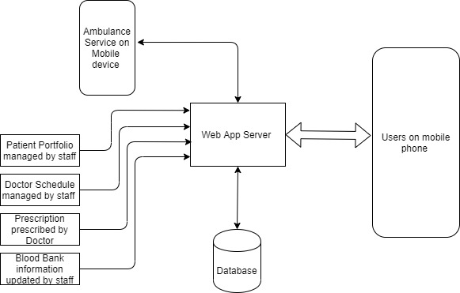

Mobile and Web Application

The users will download the application on their phones and use the different functionalities (Mobile Application)

The hospital uses the web application to update the database which the users are connected to with information regarding the doctor availability, blood bank blood group availability and patient documents (Web application)

1. *Patient Compliance Module*
2. After consultation, the doctor prescribes medicine to the patient, using the E-Prescription service, through his/her Web app.
3. This in turn, stores the prescription medicine details in the database.
4. The patient has access to the database through his/her account created on the mobile app, which can be accessed anytime and anywhere.
5. Another feature of this module comprises reminders for the timely consumption of medicines by the patient.
6. *Ambulance Service Module*
7. Incase of medical emergency a user will have to start the app with GPS enabled on his/her device
8. The application contacts a server that keeps track of  all the ambulances in the area and their proximity to the casualty - It determines based on severity, no of victims and position the most suitable ambulance that can arrive and send a message to the driver’s app to arrive with ambulance
9. *Blood Bank Service Module*
10. A unique ID is created for each patient donating blood
11. The blood type, unique ID and other essential information is stored by the blood bank
12. The hospital will have a means to update a database that records the amount of blood available and users can use the app to check if blood is available
13. In case a specific blood group is not available, a notification is sent to all the people who have donated blood and the person in need can directly contact them and request for blood donation.
14. *Doctor Appointment Module*
15. The attendance list of Doctors for the particular day is uploaded by the medical staff to the Server List via the Web App.
16. The patient logs in through his web app and chooses the Doctor availability option.
17. The list is displayed on the database, and can be accessed by the patient to view the availability of doctors.
18. *Patient Portfolio Management Module*
19. A unique ID (Phone.no) is created for each patient in the hospital
20. The ID along with the file associated for the patient is stored in fact tables in a database
21. Patients who log in with the app will be able to download the file and see the reports/scans at any time
22. Files will be deleted after a month in order to prevent storage from getting full

*b) Flow Diagrams*

(1) Doctor Availability

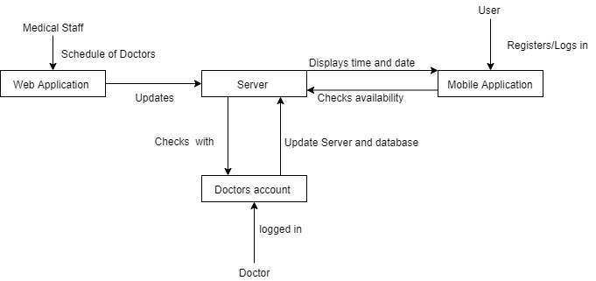

(2) E-Prescription

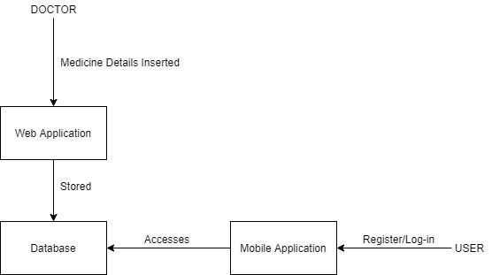

(3) Patient Portfolio



(4) Blood Donation

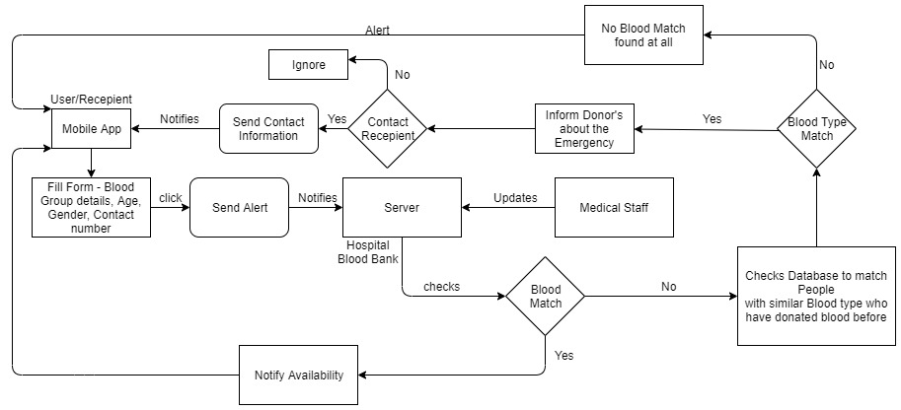

(5) Ambulance Locator

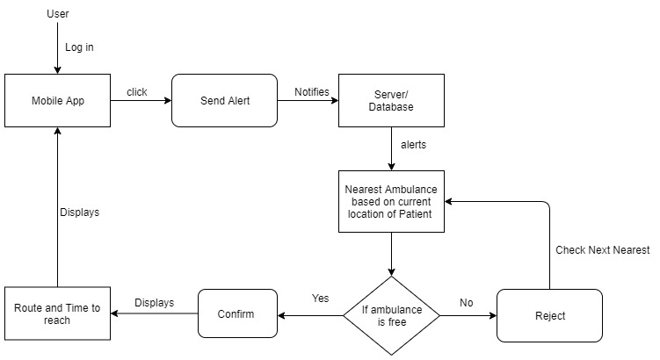

1. CONCLUSION

The motivating insight on this research is that manual work becomes time-consuming and untidy process hence there is need of applications with which Healthcare Management process can be efficiently done. Using web development and mobile application techniques this process becomes more software oriented thus aiding a person to utilize medical facilities on time.

We can conclude that the hospital management system of the modern medical institution is an inevitable part of its lifecycle. Implementing the healthcare management system project helps implement policies, market hospital services, arrange the supply chain, storing all kinds of records, improve day-to-day operations, provide user communication, manage financial and human resources. This advantageous decision simplifies their interactions, covers the needs of the patients, and staff and hospital authorities. It is the usual approach of managing the hospital.

1. REFERENCES

[1] “Prevalence of medication adherence and its associated factors among patients with noncommunicable disease in rural Puducherry, South India – A facility-based cross-sectional study” --Dr. K Yuvaraj,Department of Preventive and Social Medicine, Jawaharlal Institute of Postgraduate Medical Education and Research, Pondicherry, India

[2] Shanmugasundaram, S. and Lourdusamy, R., 2011. “A comparative study of text compression algorithms”. International Journal of Wisdom Based Computing, 1(3), pp.68-76.

[3] Berman, P., Ahuja, R. and Bhandari, L., 2010. “The impoverishing effect of healthcare payments in India: new methodology and findings”. Economic and Political Weekly, pp.65-71.

[4] Eraker, S.A., Kirscht, J.P. and Becker, M.H., 1984. “Understanding and improving patient compliance”. Annals of internal medicine